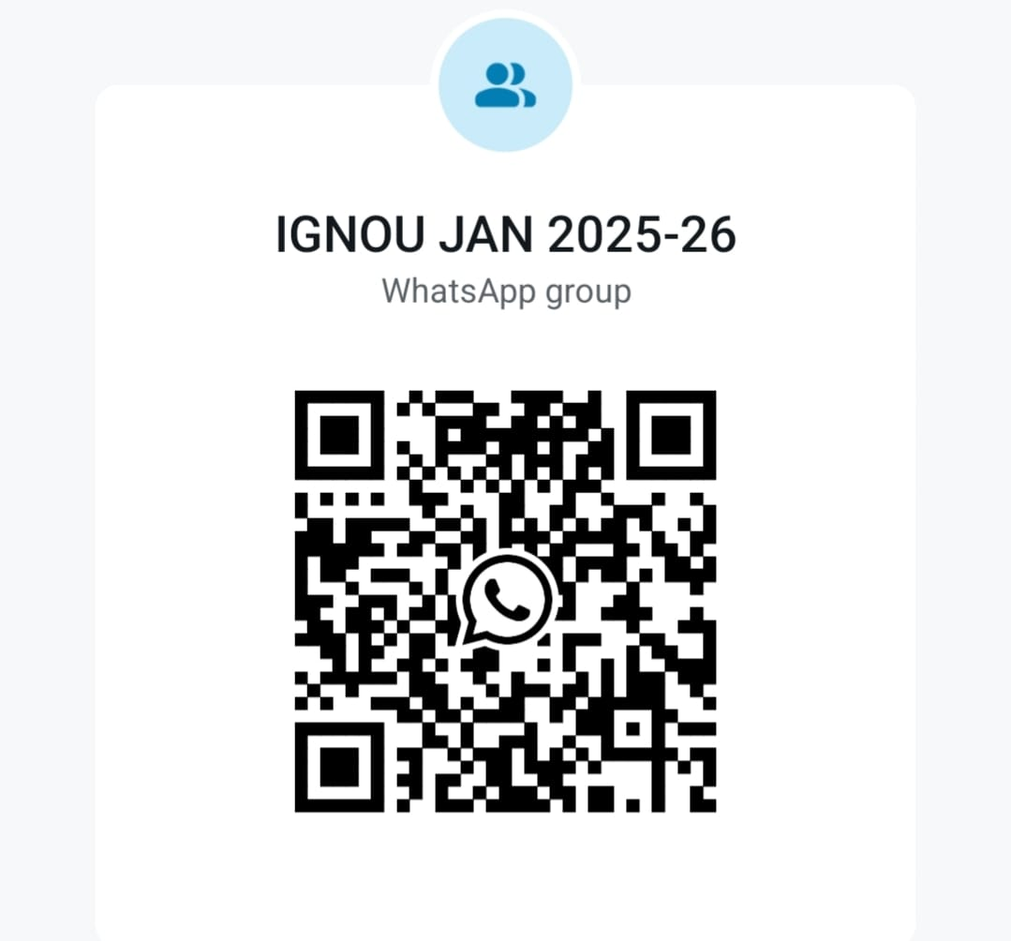

**Please Scan QR Code to join above WhatsApp group for the students of IGNOU Batch January 2025.**

**SC 1157**

**Govt. College Nalagarh**

**----------------------------------------------------------------------------------------------------**

**For any query please Contact :-**

**Sh. Ashish Kumar : 8629001808**

**Sh. Surender Pal : 9816470912**